INTERNATIONAL HINDU SCHOOL
CLASS VIII
INTERNATIONAL HINDU SCHOOL,VARANASI
CLASS VIII (2019-20)
ENGLISH
- Write the biography of the following literary figures and paste their pictures :-
- William Wordsworth
- John Keats
- Watch a movie (featured or documentary) based on education and write its review.
NOTE:- Review of the movie contains the following elements :-
- The film title
- An eye catching heading
- The genre ( type of film)
- The audience (who is the film for?)
- The plot
- Your opinion
- Your evaluation
- Collect the English newspaper cuttings related to the following topics and create a collage.( on any of the 6 topics)
TOPICS:-
- Projects by government of India :
- Namami Gange f) Kushal Bharat Yojana
- Swachh Bharat Abhiyan g) Make in India
- Ayusman Bharat h) Midday Meal Scheme
- Ujwala Yojna i) Beti padhao beti bachao yojana
- Digital India
- Make a poster on any one of the following topics;-
- Swachh Bharat Abhiyan
- Endangered Species
- Environmental Degradation
- Global warming
- Namami Gange
- Complete the exercise (p.g. 154 to 157), grammar book and learn the antonyms and synonyms given in your grammar book.

MATHEMATICS
- Solve all the exercises based on Rational number from R.S. Agarwal book.
- Solve all the exercises based on Linear Equation from R.S. Agarwal book.
- Solve all the exercises based on Square and Square root from R.S. Agarwal book.
- Solve all the exercises based on Cube and Cube root from R.S. Agarwal book.
- Solve all the exercises based on Practices from R.S. Agarwal book at least two hours daily and sample papers.
- Write and learn all properties. ( closure property, commutative P, associative P, distributive P, additive identity, multiplicative inverse, role of zero and one.
- Write and learn all formulas from basic Geometrical idea ( all quadrilaterals ).
- Write and learn all identities from algebra.
- Learn all the formulas of Perimeter and Area of all basic geometrical polygon figures.
- Project :-
- Collect the information about the currency of different countries and make a comparison study with Indian currency. (Minimum 25 Countries).
- Classification of polygons with figures (convex and concave, regular and irregular polygons).
SCIENCE
- Collect the picture of 10 laureates. Write about their achievement.
- Collect different types of grains and label them.
- Make a list of gram-positive and gram-negative bacteria

SOCIAL SCIENCE
- Write some innovative ideas to perform Swacha Bharat Abhiyan and how it can be effective.
- Write a short note on Indian constitution? Write a short biography of “the father of Indian constitution” and paste his picture.
- Draw a poster of “swacha Bharat swastha Bharat” (A4 size chart paper).
- What is Indian model of secularism?
- Prepare a collage on the recent electing that is taking part in our country.
- Watch a video on the series of samvidhan on Rajyasabha T.V and write a short note on it.

fgUnh
1- Okjk.klh ds rhu egku dfo;ksa ,oa ys[kdksa dk lfp= thou ifjp; nsrs gq, ,d ifj;kstuk dk;Z rS;kj djsA
2- ikB~; iqLrd ds vk/kkj ij d{kk esa djk, x, lHkh iz’uksa ds mÙkj ;kn djsA
3- fuca/k ys[ku rS;kj dhft,A
d- esjs thou dk y{;
[k- ou gh thou gSA
x- I;kjk Hkkjr o"kZA
?k- [ksy dk egRo
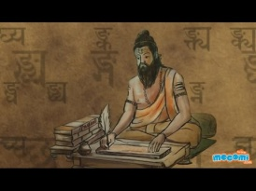
laLd`r
1- x`g mi;ksxh 20 oLrqkvsa ds uke laLd`r esa fp= ds lkFk fy[kksA
2- fo|qr midj.kksa ds uke laLd`r esa fp= ds lkFk fy[kksA ¼10&12½
3- ckyd yrk vkSj iqLrd dk :I fy[kks vkSj ;kn djksA
4- iB~] xe~ fy[k] Hkw vkSj ik dk :i ik¡pksa ydkj esa fy[kks vkSj ;kn djksA
5- d{kk ds 10 fo|kfFkZ;ksa ds uke fy[kdj mudk o.kZ&foPNsn djksA

COMPUTER
- What is network and what is its significance? Draw or paste the picture of different types of networks and write about it.
- What do you mean by social networking sites? What precautions should we follow while using social networks?
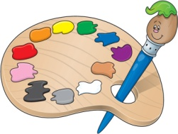
DRAWING
- Draw a collage showing different colors of summer.

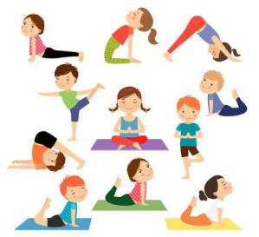
YOGA
1. Elaborate five Asana on the chart paper with suitable diagram.
- Describe 2 Pranayama along with its benefits and precautions to be taken while doing it.

Lkaxhr
1- AUTHOR OF BEAUTY PRAYER dks ;kn djds vkuk gSA
2- nknjk rky dks rkyh] [kkyh] ek=k ;kn djuk gSA
3- n;kdj nku fo|k dk izkFkZuk ;kn djuk gSA
4- rcys dk fp= laxhr dh dkih esa cukdj ;k dgha ls dkVdj mlds ckjs esa fy[kuk gSA
5- vkjksg ,oa vojksg dh ifjHkk"kk ;kn djuk gSA

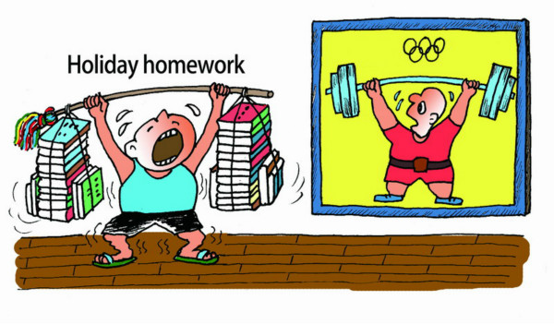
Pick a time of day to do your homework…..
TIPS TO REDUCE STRESS OF========
- Start large projects as early as possible….
- Make yourself a homework schedule…..
- Take good notes…..
- Create a space dedicated to homework and studying. ….
- Eliminate all distractions and avoid multitasking…..
- Take breaks….
- Avoid over committing yourself…..
- Make sure you get enough rest……
- Decide your priorities
- Practice good time management. Time management is key to avoiding homework stress. ...
- Ask questions. ...
- Try group study sessions
- Allow more time for areas you find difficult. ...
- Refresh your memory regularly. ...
- Get a good night's sleep. ...
- Avoid procrastination. ...
- Have a healthy snack

