INTERNATIONAL HINDU SCHOOL
SESSION – 2019 -20
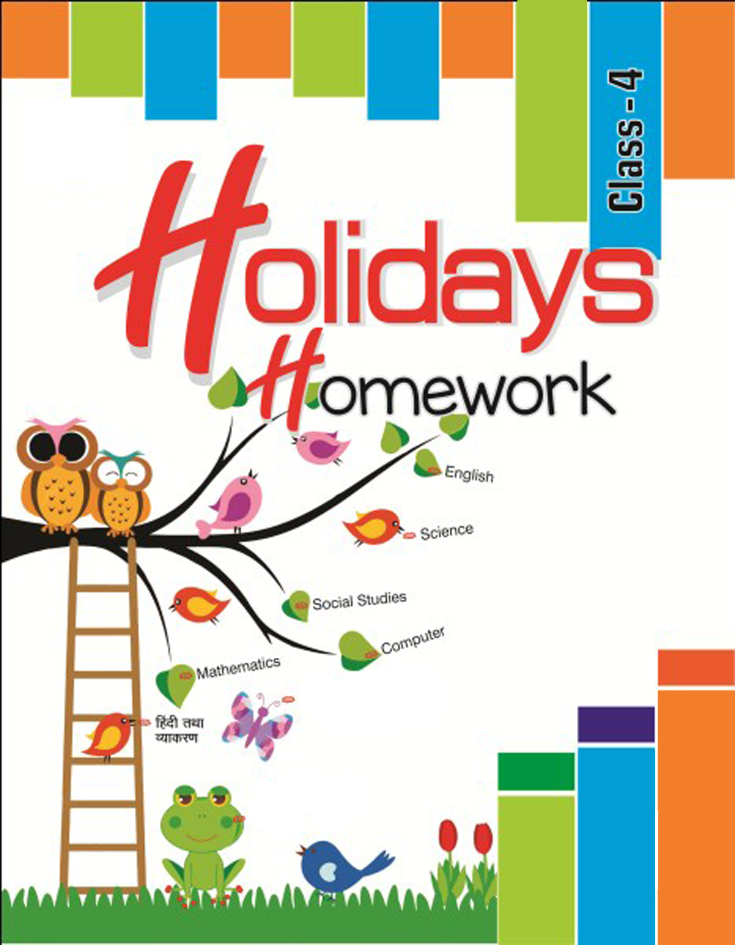

English
- Do loud reading daily. (From newspaper, storybook, textbook).
Write hard words, their meaning and make sentences.
- Do one page handwriting daily with day and date. (make separate copy)
- Learn poems written by William Wordsworth.
- Read folk tales.
- Do revision of the portion which has been taught.
- In Grammar copy do these exercises – page 2 Ex-A, page 3 Ex-B, page no. 9 to 10 Ex-D and page 17 Ex-E.

Mathematics
- Write the roman numbers from 1 to 200.
- Learn and write the multiplication table from 10 to 25.
- Do all the question of Ex-4A and Ex-4B in your copy.
- On a chart paper write the roman number 1 to 50 with the help of matchsticks.
- Prepare a clock.
- Fill in 1 to 6 to get a sum of 11 along each line. Use each number only once.
- Fill in 1 to 8 to get a sum of 14 along each line. Use each number only once.

Computer

- Write a brief history of computer.
- What are input and output devices.

Science
- Write about pollution, its causes and prevention and paste picture also.
- Write names of any 5 national parks/ wildlife sanctuaries with their location.
- Paste the pictures and write about any 5 endangered/ extinct animals.
- Paste picture of any 5 traditional costumes.
- Make diagram of traffic light. State the meaning of every color in the traffic light. Write 10 safety rules.

Social studies.
- On an outline map of India, mark the boundaries, name the neighboring countries and all the states, color the largest state blue and smallest state yellow. Paste it in a file.
- Collect information about famous Indian and world mountaineers who climbed the Mt. Everest (at least 5 person).
- Write 4 views about the advantages and disadvantages of mobile phone.
- Collect pictures of people, monuments, historical places, festivals, dances, food, crops, etc of any state in India. Paste it in file and write about them.

Hindi
fo"k;& fgUnh
- izfrfnu ,d ist+ lqys[k fy[kuk gSaA rkjh[k ds lkFk] izfrfnu nks ist+
i<+uk Hkh gSA
- i<+kbZ ds lkFk [ksydwn Hkh vko’;d gS] vius fiz; ik¡p [ksyksa ds ckjs esa fy[ks] ,oa muds fp=ksa dk dksykt cuk;s] Scrap book esa
- ?kj esa iz;ksx u gksus okyh VwVh ,oe~ vU; [kjkc oLrqvksa ls ,d mi;ksxh oLrq dk fuekZ.k djksA
- viuh O;kdj.k dh fdrkc ^xfjek* ls 15 foykse 'kCn ,oe~ 10 i;kZ;okph 'kCn] 10 vusd 'kCnksa ds fy, ,d 'kCn ;kn djds viuh O;kdj.k dh
dkWih esa fy[kuk gSA
- fuEu fo"k;ksa ij ,d vuqPNsn fy[kks&
- Hkkjr dk jk"Vªh; i{kh
- esjk I;kjk xkWo
- viuh ek¡ ds ?kjsyw dk;ksZa esa enn djuk gSaA

