**International Hindu School**

**Holiday Homework (2019-20)**

**Class – L.K.G**

**This holiday homework belongs to:-____________**



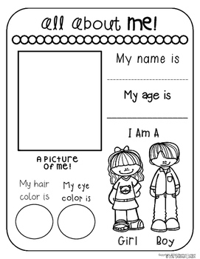

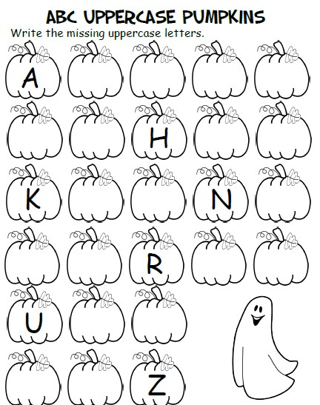

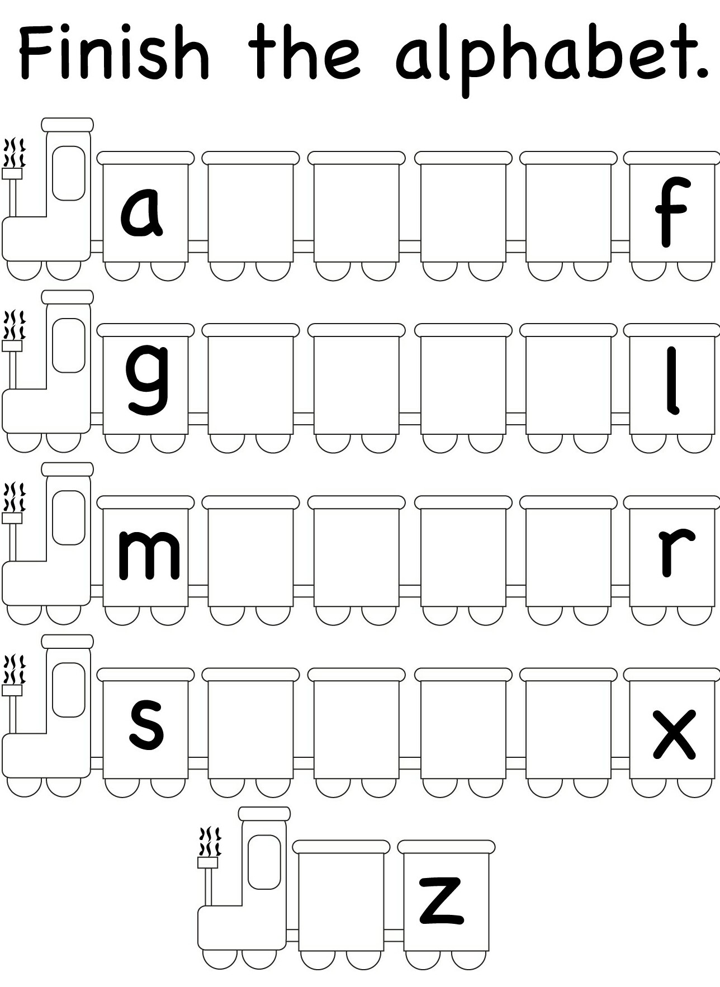

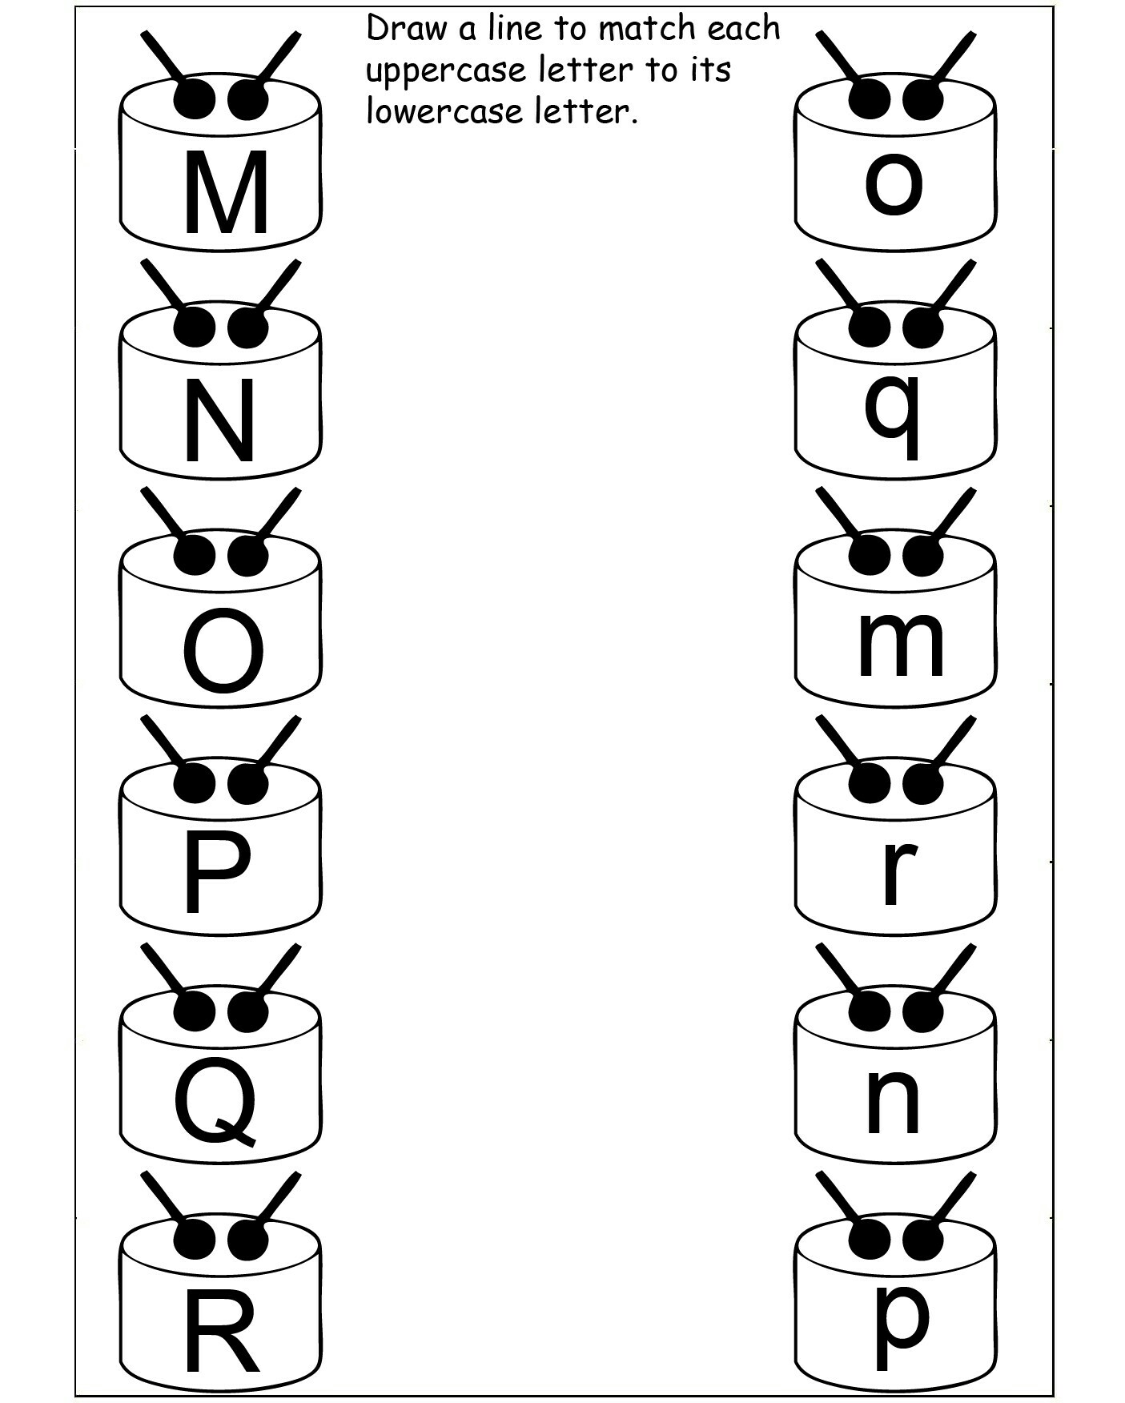

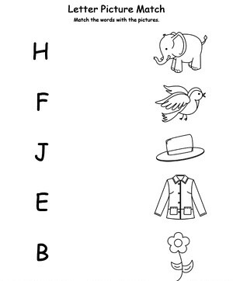

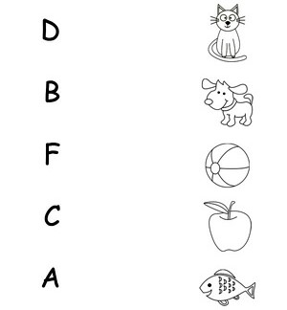

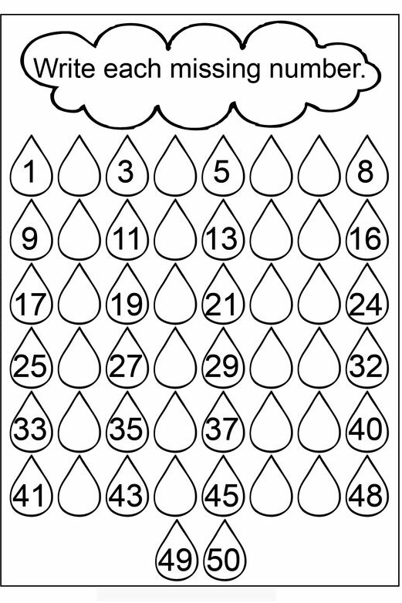

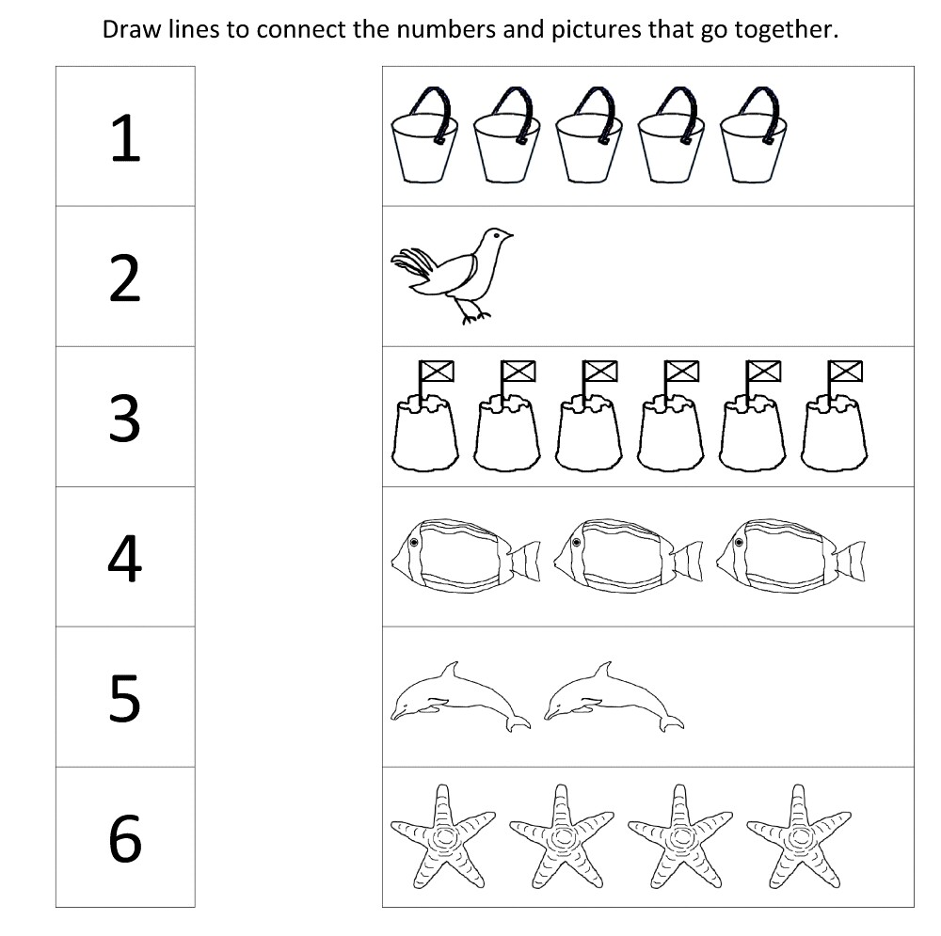

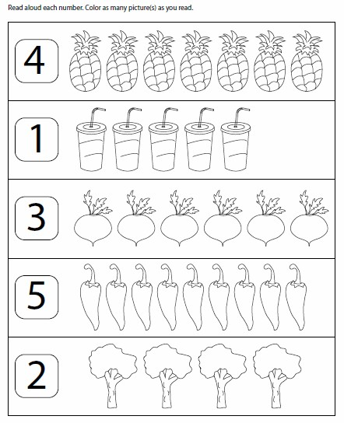I

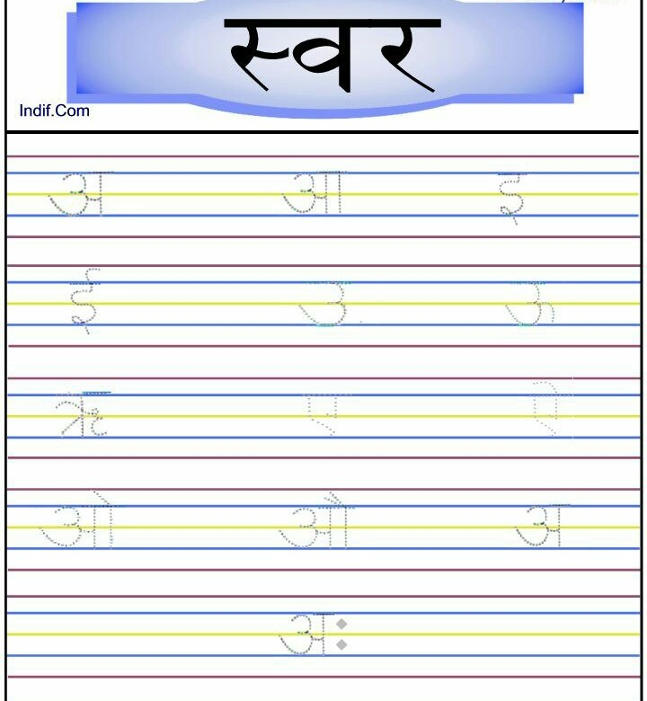

**Match Worksheet**

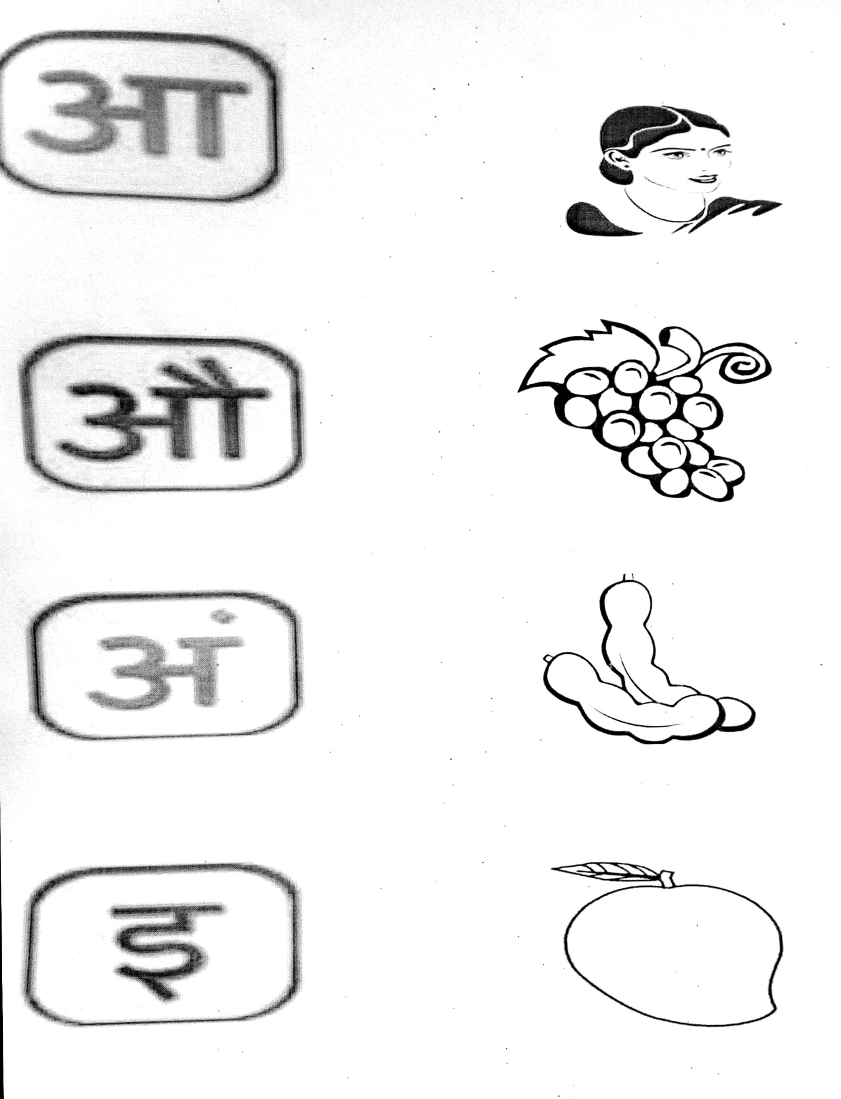



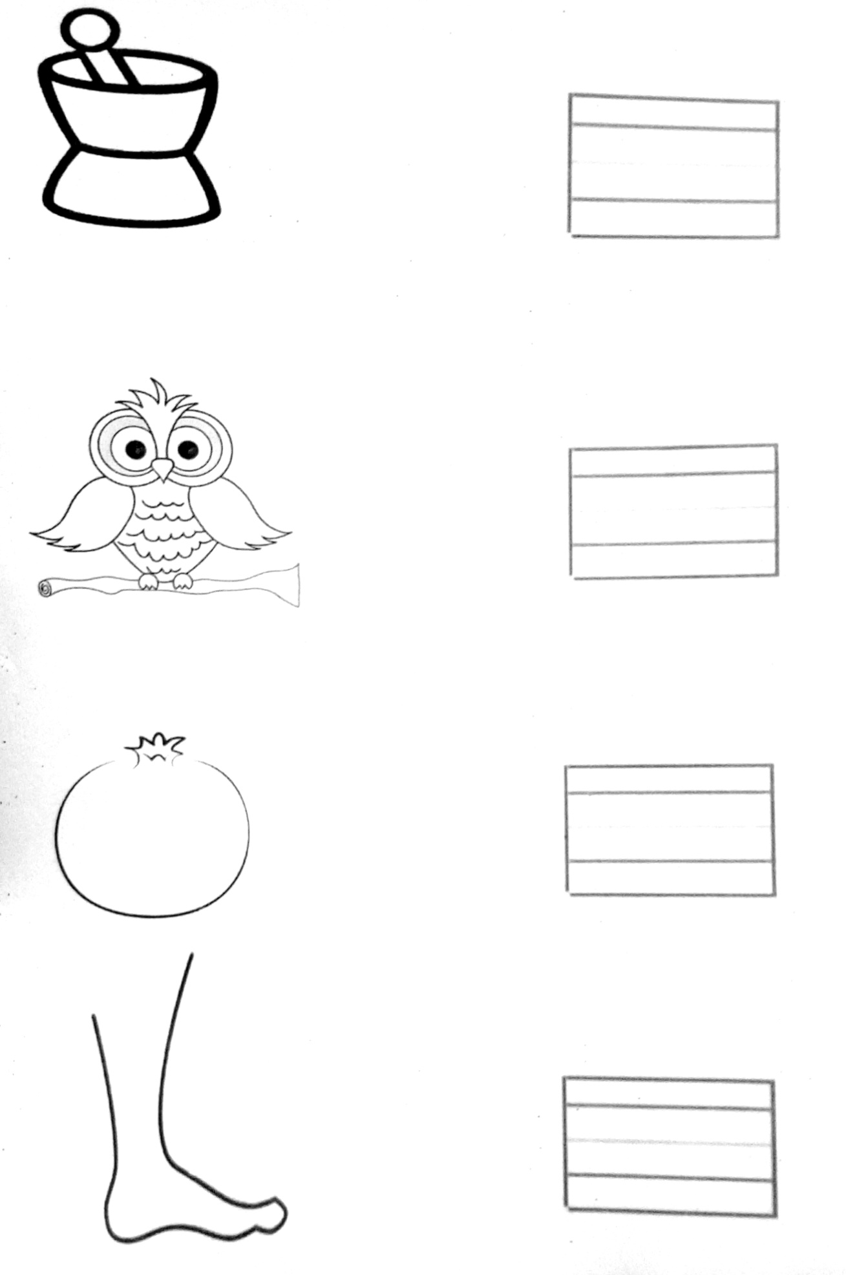

**Paste Pictures of Fruits.**

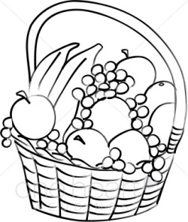

**Paste pictures of vegetables**

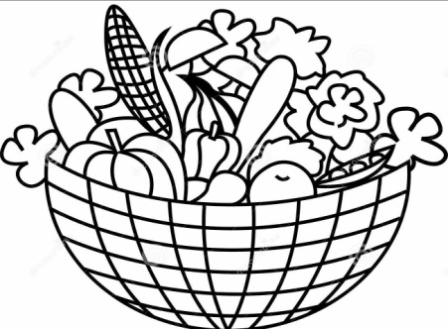

**Colour the bigger animals in green and smaller animals in red.**

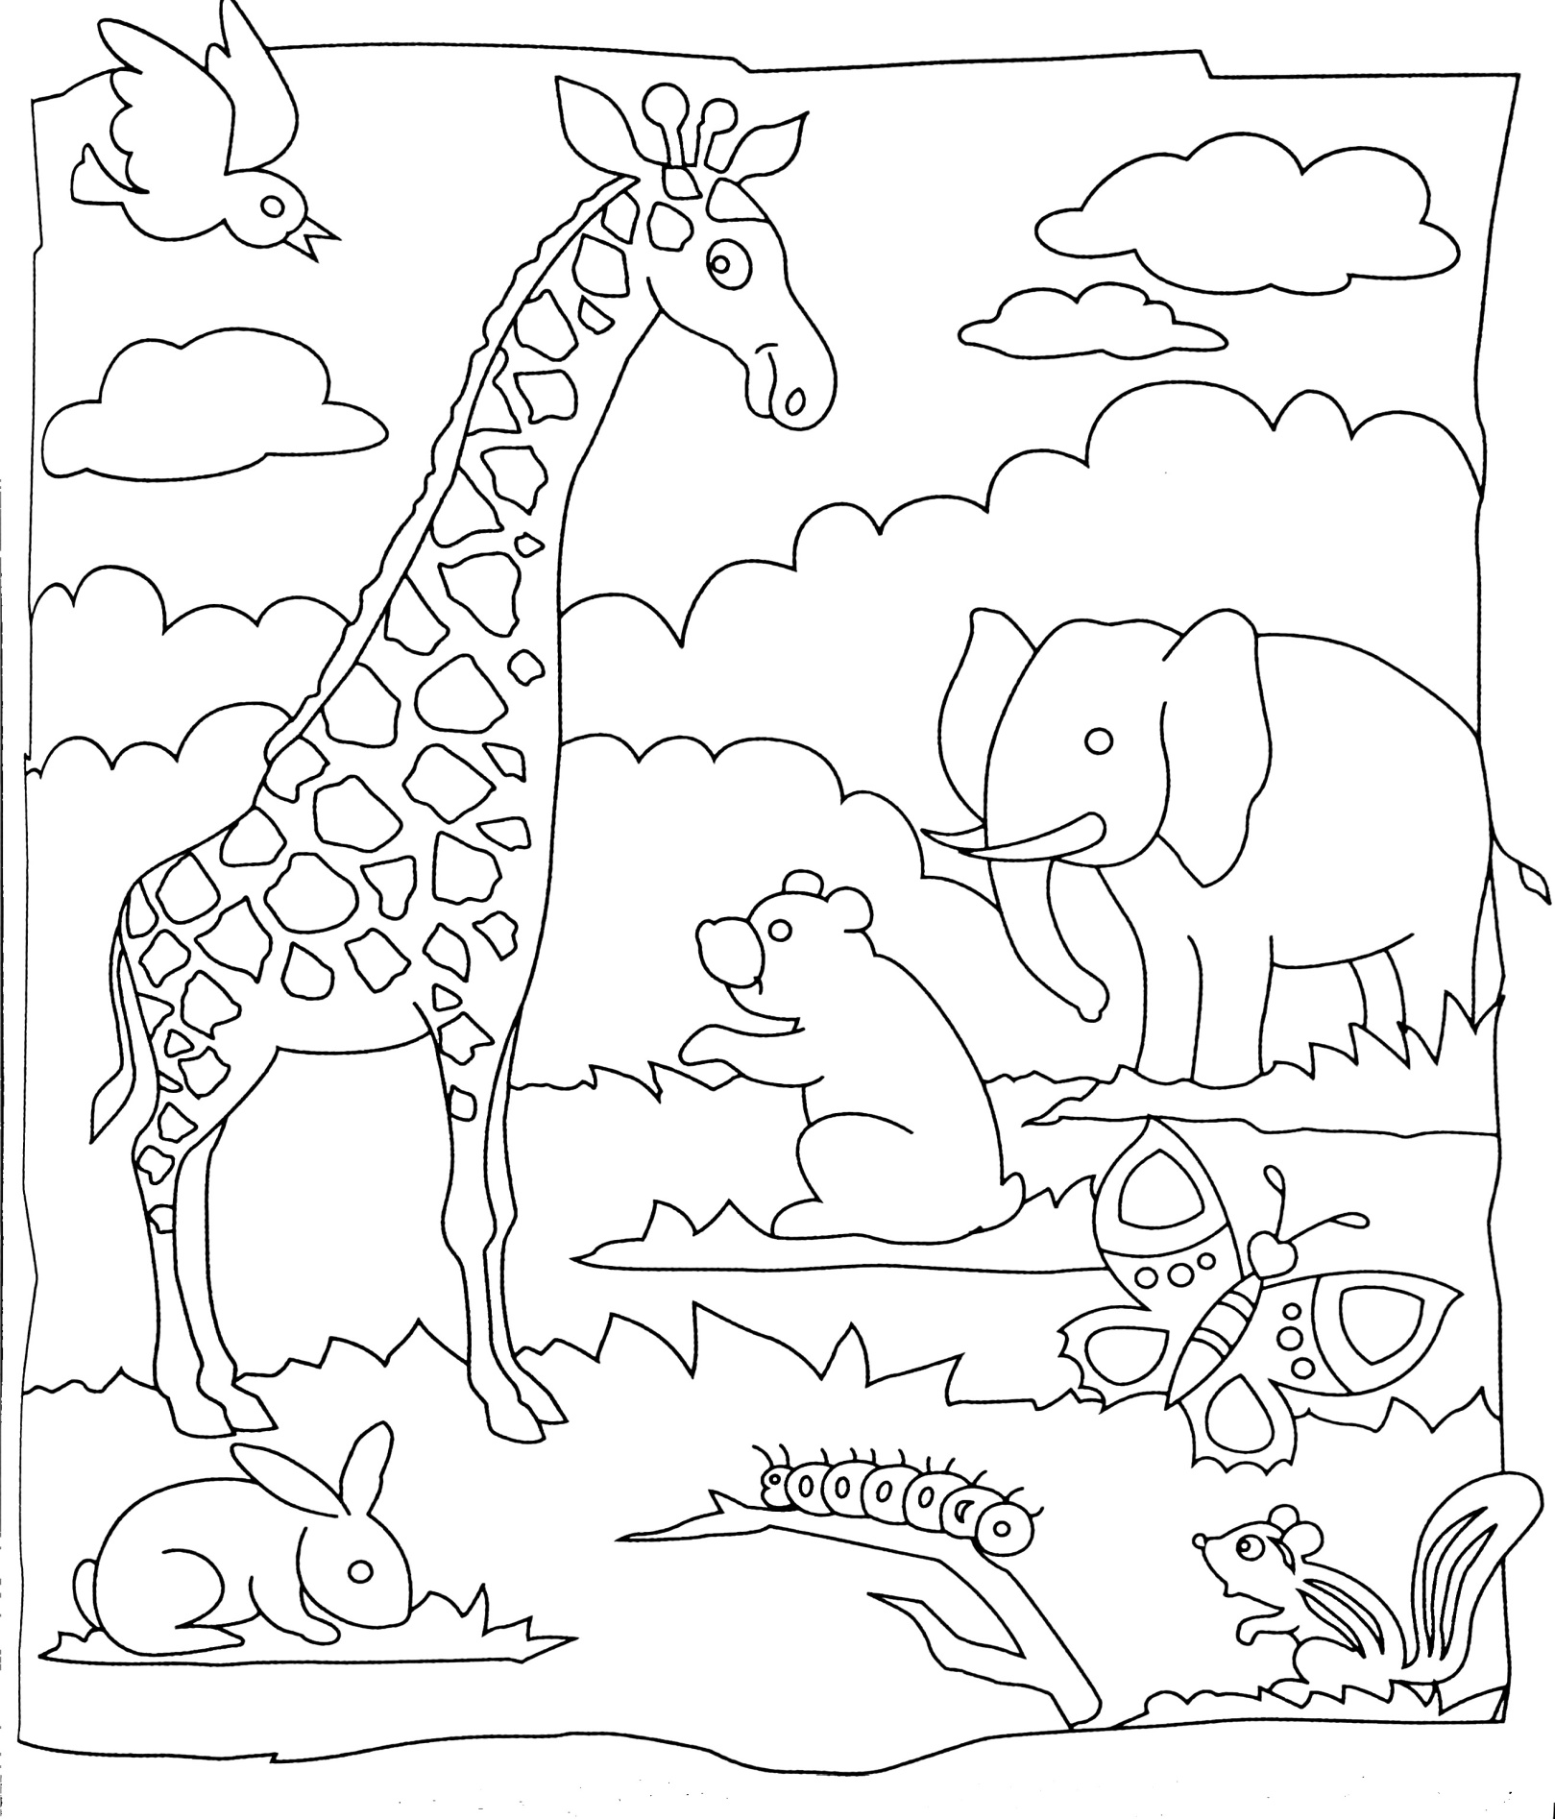

**Colour it..**

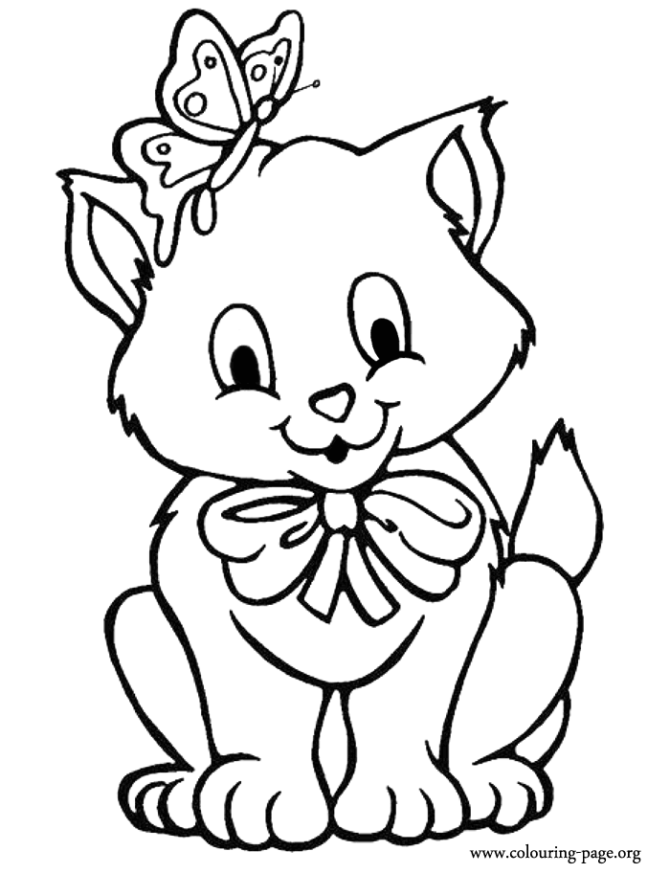

**Cut a lady finger into pieces and dip it into thick watercolours and make impression on the tree.**

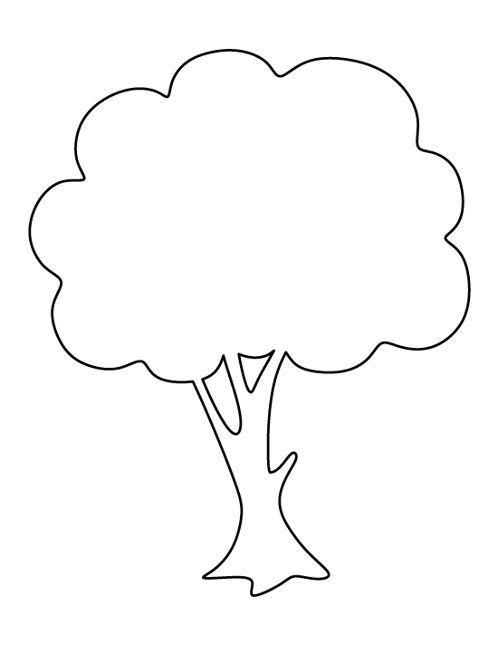

**Fun activity:-**

* Sow a seed in a beautiful pot. Water it daily. Measure the height of the plant weekly and make a report. Bring it with you after the vacation.
* With help of A3 size Chart paper, draw and write any one rhyme of your choice.

We hope you will enjoy these activities and come back to school with a new zeal and enthusiasm.



**Have a happy and cheerful vacation**