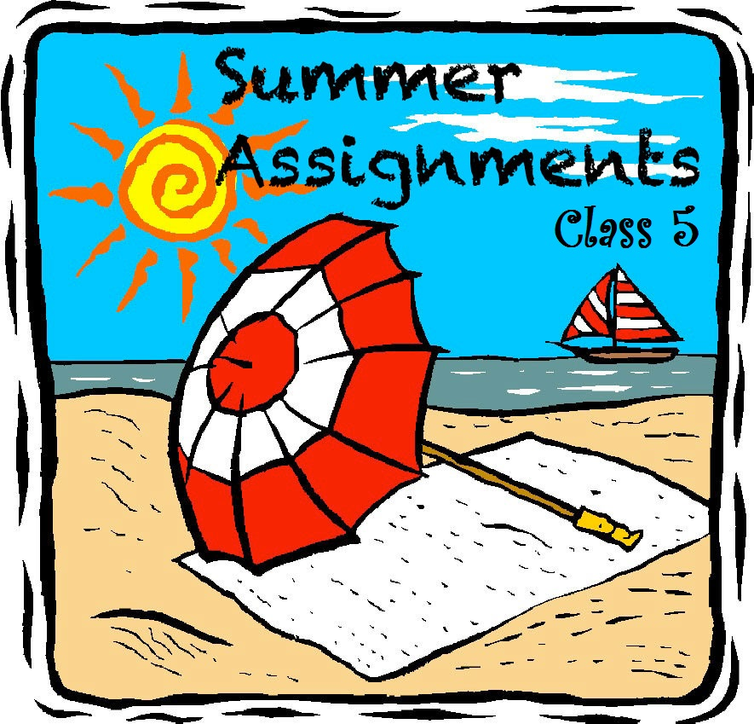
Class 5- Summer Holidays Homework
Maths-
- Write Roman Numerals from 1 to 500.
- Paste pictures and write about the famous mathematicians- Any 6
- Brahmagupta
- C.R. Rao
- Aryabhatta
- Srinivasa Ramanujan
- Bhabha
- Issac Newton
- Leonard
- Albert Einstein
- Choose any five packed food items, paste their empty packets and note down their name, MRP and estimated MRP in a table.
- Write down the maximum and minimum temperatures of 10 consecutive days in June in a table.
- Paste matchsticks to make different types of triangles, based on-
- Angles- right, acute, obtuse
- Length- equilateral, isosceles and scalene.
Science-
- Write about Global Warming, its causes and effects. Role of Green House Gases in Global Warming.
- Collect leaves of five herbs or plants, dry their leaves and paste it in your file. Write about their usefulness in our daily life.
- Learn to make your favorite dish. Write its recipe and Nutritive Value.
- Collect information about any 5 endangered/extinct animals. Paste their pictures and write about them.
- Cut and paste 5 news articles related to science from newspaper.
- Paste pictures and write a paragraph about Proxima Centauri.

English-
- Write an autobiography of Rudyard Kipling.
- Write a paragraph on “Deeds of kindness” and importance of friendship”
- Prepare a magazine based on Bollywood news, health tips, beauty tips, short stories, sports news jokes, recipe, political news updates.
- Daily new vocabulary hunt.
- Share an incident with your elbow friend when you wanted to give up on something but didn’t and your determination paid off.
Social Studies-
- Make a model of a volcano using clay or dough and label it parts.
- Collect pictures from newspaper and magazines and make an album on ”The havoc of earthquakes and volcanic activities”.
- Collect pictures and make an album of some pilgrim centers of various religions. Write a few sentences about it.
- Make placards and banners urging everyone to stop using plastic.
- Find out the names of the four longest rivers in Africa and write few sentences about each.
- With the help of an atlas, write the names of four major lakes in Africa.

Computer-
- Write a brief history of computer.
- How to create a file or folder. Write its process.

fgUnh
- izfrfnu nks ist+ lqys[k fy[kuk gSa fnukad lfgr ,oa ikB dks izfrfnu i<+dj vH;kl djsaxsA
- vuqPNsn ys[ku&¼esjk fiz; f[kykM+h½ ,oe~ ¼esgur dk Qy ehBk gksrk gS½
- Scrap book esa vius ilanhnk ys[kdksa ds fo"k; esa tkudkjh ,oa fp= fpidk;sa ?kj esa iM+s Waste material ls mi;ksxh oLrqvksa dk fuekZ.k djsaxsA
- viuh ikB~; iqLrd ¼xfjek O;kdj.k½ ls ^^fo|ky; ds ykHk** ls ij fucU/k ;kn djds O;kdj.k dh dkWih esa fy[kuk gSA
- NqfV~V;ksa esa viuh eEeh dh muds dk;ksZa esa enn djsaxsA

