INTERNATIONAL HINDU SCHOOL
CLASS VI

CLASS VI
INTERNATIONAL HINDU SCHOOL

ENGLISH
1. Complete homophones in grammar book (page no. 149).
2. Learn the idioms given on page no. 153 from grammar book.
3. Write a short biography of the following poets and paste their pictures:-
- William Wordsworth
- William Shakespeare
4. Write poem daffodils and make pop up daffodils craft.
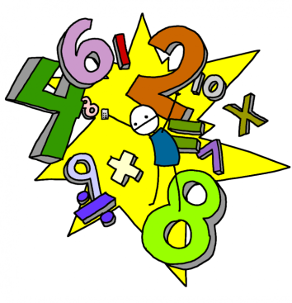
5. Draw a poster on “CLEAN INDIA GREEN INDIA” and write a short paragraph on it.
MATHEMATICS
1. Answer the following:
- Mathematics is the study of ___________________.
- 1, 2, 3, 4, 5, Numbers are known as__________________.
- 0,1,2,3,4,5………. Numbers are known as__________________.
- ….-4,-3,-2,-1,0,+1,+2,+3,+4……. Are known as________________ or _____________.
- Zero is neither ___________ nor _____________.
- One million four hundred and eight thousand, nine hundred and fifty-seven _______________(write in numerals)
- Seventy lakh, eighty three thousand seven hundred and nine_______________(write in numerals)
- The place value of a digit is depends on the____________ in the number in relation to other numbers.
- The face value of the number is of a digit in a number is the ______________itself.
- If a place value and face value of a number is same, then it is in the______________ place.
- The Roman numeral of 94 is____________.
- A crore has_____________ lakh.
- The successor of 999 is ______________.
- Even number is divided by_______________.
________________ is the smallest natural number.
2. Insert comma suitably ad write the number name of the following according to the Indian system of numeration:-
- 16573449
- 287651009
3. Write the first five multiples of “8”.
4. Find the sum by suitable arrangement:-
- 832+553+168+447
- 3578 x 123 - 3578 x 23

5. Write the numeral of “Ten crore sixty five lakhs twenty one thousand sixty three”.
6. Find the product by suitable arrangement 4x165x25.
7. Draw the factor tree of 48.
8. Find the product of 85x102 using distributive property.
9. Raju had Rs.6980/- with him. He brought a fan for Rs.1900/- and a music system for Rs.3080/-. Find the amount that is left with Raju.
10.
- Add:- 24560+379+1467
- Subtract:- 9457 from 16115
- Multiply:- 29840 by 26
- Divide:- 56646 by 27
11. Complete each magic square. Use any whole number 1-15. Each number cannot be used more than two times in each magic square:
Magic sum=15 Magic sum=21 Magic sum=24 Magic sum=30
9
 | 10 | 5
 | 5 | 6
4
 |  | 4
 | 7 | 9
7
8
10

SCIENCE
1. Paste a sprouted seed and label its parts. What are the health benefits of eating sprouts? Explain.
2. Paste seedlings and label its parts.
3. Make beautiful design with the help of seeds.
4. Collect and paste two types of each:
- Plant fibre
- Animal fiber
SOCIAL STUDIES
1. Draw a diagram of Indian Flag and write down its history.
2. Draw a diagram of the globe showing the earth axis, the equator, the tropic of cancer, tropic of Capricorn, Antarctic and Arctic Circle.
3. Make a model of solar system.
4. What was jalliawalabagh massacre? Describe it.

fgUnh
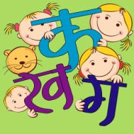
- jk"Vªh; fpUgksa Qwy] i{kh] Qy] i’kq] [ksy] xku] xhr] isM+ feBkbZ ds ckjs esa fyf[k, vkSj muds fp= fpidkb,A
- ohj jl ds ik¡p dfo;ksa dks ckjs esa fyf[k,A
- vkius viuh xjeh dh NqV~Vh;k dSls fcrkbZ Mk;jh fyf[k,A
- v{k; mtkZ fdrus izdkj dh gksrh gS\ muds ckjs esa fyf[k, vkSj muls pyus okys dqN midj.kksa ds fp= fpidkb, vkSj muds esa ckjs esa fyf[k,A
- vius {ks= esa lQy ¼tSls& jktuhfr] [ksy] m|ksx bR;kfn½ fdUgha ik¡p Hkkjrh; efgykvksa ds mudh miyfC/k;ksa ds ckjs esa tkudkjh nsrs gq, ifj;kstuk cukb,A
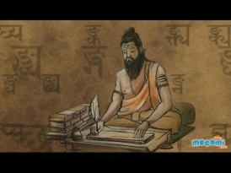
laLd`r
- ikB 1 dk dksbZ Hkh nks vuqPNsn fy[kdj mudk fgUnh vuqokn cukvksA
- rhuksa fyaxksa ls 10&10 okD; mnkgj.k lfgr cukvksa vkSj fy[kksaA
- la[;k ¼fxurh½ 1 ls 50 rd laLd`r esa fy[kksA
- jke] d`frdk] ds 'kCn :i vkSj iB] xPN ds /kkrq :i rFkk rhuksa ydkjksa esa fyf[k,A
- ¼d½ 20 ?kjsyw oLrqvksa ds uke fp= lfgr fyf[k,A
¼[k½ vius fo|ky; ds fo"k; esa 100 'kCnksa esa laLd`r esa fp= lfgr fy[ksaA
¼x½ dksbZ ,d oLrq dk fp= cukdj mlds ckjs esa fyf[k,A

COMPUTER
1. What is Computer language? Explain.
2. How to burn CD/DVD. Write its steps.

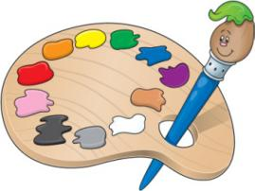
DRAWING
1. Make a collage, showing different colors of summer.
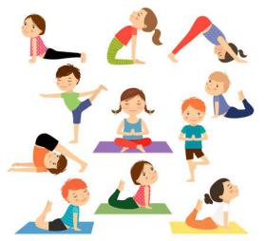

YOGA
1. Elaborate five asana on the chart paper with suitable diagram.
2. Write about the health benefits of pranayama and what precautions to be taken while doing it.
laxhr
- O BE CAREFUL LITTLE EYES. ;s xkuk ;kn djuk gSA
- rky dgjok ek=k] rkyh] [kkyh] ;kn djuk gSA
- E;wftd dh dkih esa ek¡ ljLorh th dh QksVks fpidk dj muds ckjs esa fy[kuk gSA
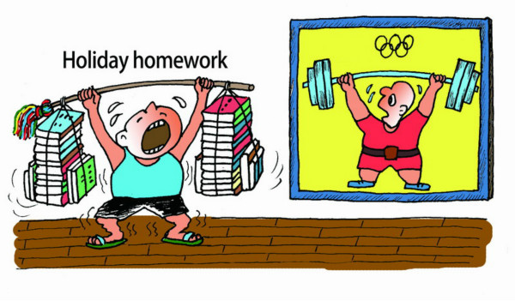
Pick a time of day to do your homework…..
TIPS TO REDUCE STRESS OF========
- Start large projects as early as possible….
- Make yourself a homework schedule…..
- Take good notes…..
- Create a space dedicated to homework and studying. ….
- Eliminate all distractions and avoid multitasking…..
- Take breaks….
- Avoid over committing yourself…..
- Make sure you get enough rest……
- Decide your priorities
- Practice good time management. Time management is key to avoiding homework stress. ...
- Ask questions. ...
- Try group study sessions
- Allow more time for areas you find difficult. ...
- Refresh your memory regularly. ...
- Get a good night's sleep. ...
- Avoid procrastination. ...
- Have a healthy snack

