INTERNATIONAL HINDU SCHOOL
CLASS VII
INTERNATIONAL HINDU SCHOOL,VARANASI
CLASS VII (2019-20)
ENGLISH
- Find out any five proverbs and their meanings. Write a sentence with each.
- Do one page of writing daily in cursive pattern.
- Find out two synonyms each of the following words:-
amazing, anger, answer, begin, break, bright, dangerous, destroy , delicious, eager
- Read any English newspaper daily. Write the meanings of any ten new words from it.
- Write a diary entry on any of one the characters from the English storybook you read.
- In a story book write a short biography of the following authors and paste their pictures:-
- William Sydney Porter
- Ella Wheeler Wilcox
- Write the rhyme scheme of the poem “ The Arrow and the Song”.
MATHEMATICS
- Solve all the exercises of Integers from R.S. Aggarwal .
- Solve all the exercises of Fractions and Decimals from R. S. Aggarwal.
- Learn all the properties of Integers i.e closure property, commutative property, associative property, distributive property, role of 0, role of 1, additive identity and multiplicative identity and verify these properties with two different examples.
- Learn Tables from 2 to 20.
- Project :
- Write about any two mathematicians and their contribution in mathematics.
- Write any 5 rules of Vedic mathematics with 3 examples of each.
SCIENCE
Do the following activities :-
- Make table 3.1, some Indian breeds of sheep (from p.g.26, NCERT BOOK) and write about occupational hazards. (p.g 28)
- Draw the life cycle of History of Silk moth. (fig.3.9)
- Do an experiment using plane tap water and salted water and observe the freezing and boiling point of both..
- Collect and paste different types of silk and write their names.
OR
Draw the diagram on photosynthesis from book (p.g.3, fig 1.3) and write the chemical equation of it.

SOCIAL STUDIES
- Paste the pictures of different types of historical sources (like coins, inscription, monuments, sculptures, paintings and books) and write 5-5 lines about them.
- Write about different types of Rock and also paste their pictures.
- Write a short note on different types of government like monarchy, dictatorship etc.
fgUnh
- fgUnh lkfgR; ds izfl) rhu ys[kd ,oa rhu dfo;ksa dk thou ifjp; fp= lfgr fy[ksa tks okjk.klh ls lacaf/kr gSA ¼Scrap book½
- iksLVj cukb, fuEu fcUnqvksa esa ls fdlh ij
- i;kZoj.k cpkuk gS
- xaxk D;ks iznwf"kr gS
- ek¡ vFkkZr bZ’oj dSls\
- thou la?k"kZ gSA
- vuqPNsn fyf[k, fdlh ,d
- ;ksx D;k gSaA
- fiz; [ksy] ,oa fiz; f[kykM+hA
4- ikB~; iqLrd xfjek fgUnh O;kdj.k ls ¼20½ foykse 'kCn] 20 vusdkFkhZ] 20 le:ih fHkUukFkZd] fy[ks O;kdj.k dkih esaA
5- d{kk esa djk fn;s x;s dk;ksZa dk ;kn djsaxsA
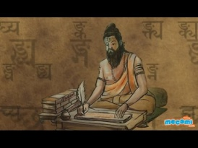
laLd`r
- iB~] xe~] fy[k~] Hkw] vkSj] ik /kkrq dk #i ikWpksa ydkjksa esa fy[kks vkSj ;kn djksA
- la[;kokph 'kCnksa dks 1 ls 10 rd laLd`r esa fy[kksaA
- laLd`r ds ikWp egkdfo;ksa ds ckjs esa lfp= o.kZu djsA
- yrk] unh] Hkkuw] vLHkn~ vkSj ;qL;n dk :i fy[kks vkSj ;kn djksA
- ?kjsyw oLrqvksa ds uke laLd`r esa fy[kksa vkSj fp= fpidkvksaA

COMPUTER
- What is a memory? Define Internal and External memory and describe its type.
- What is a Number System? Explain with diagram.
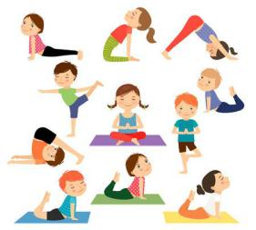

YOGA
- Elaborate five Asana on the chart paper with suitable diagram.
- Describe 2 Pranayama along with its benefits and precautions to be taken while doing it.

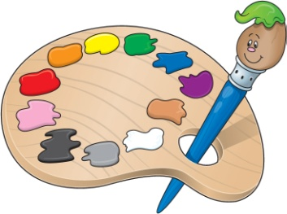
DRAWING
- Draw a collage showing different colors of summer.
laxhr
1- laxhr dh ifjHkk"kk ;kn djuk gSA
2- dgjok ek=k] rkyh] [kkyh] ;kn djds vkuk gSA
3- bruh 'kfDr gesa ns uk nkrk izkFkZuk dks ;kn djuk gSA
4- laxhr ds dkih esa gkjeksfu;e dk fp= cukdj muds ckjs esa fy[kdj ykuk gSA

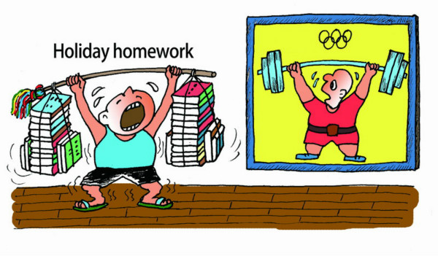
Pick a time of day to do your homework…..
TIPS TO REDUCE STRESS OF========
- Start large projects as early as possible….
- Make yourself a homework schedule…..
- Take good notes…..
- Create a space dedicated to homework and studying. ….
- Eliminate all distractions and avoid multitasking…..
- Take breaks….
- Avoid over committing yourself…..
- Make sure you get enough rest……
- Decide your priorities
- Practice good time management. Time management is key to avoiding homework stress. ...
- Ask questions. ...
- Try group study sessions
- Allow more time for areas you find difficult. ...
- Refresh your memory regularly. ...
- Get a good night's sleep. ...
- Avoid procrastination. ...
- Have a healthy snack

