Online Education in Psychology
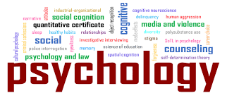
According to the American Psychological Association. Psychology is a multifaceted discipline and includes many sub-fields of study such areas as human development, sports, health, clinical, social behavior and cognitive processes.
Psychology is the study of human behavior and mental processes. Psychologists study a person’s reactions, emotions, and behavior, and apply their understanding of that behavior to treat the associated behavioral problems.

Career Scope :

1.Clinical Psychologist 2.Counseling Psychologist 3.Health Psychologist 4.Teaching and Research 5.Industrial/Organizational Psychologist 6.Sports Psychologist 7.Agency/Community 8.Counselor Educational Psychologist 9.School Counselor 10.School Psychologist 11. Social Worker
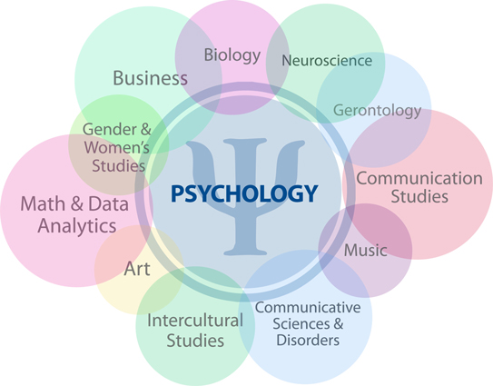
Online courses :

- CPD Accredited Special Educational Needs Course
United Kingdom , London

- Course in Counseling and Psychology
United Kingdom , London

- Course in Criminal Psychology
United Kingdom , London

- Course: CACHE Childcare and Education Level 3 Award (QCF)
United Kingdom , UK Online
- Course: Counselling & CBT Training
USA , USA Online , United Kingdom , UK Online

- A Level Psychology Course
United Kingdom , UK Online

FAMOUS PSYCHOLOGIST

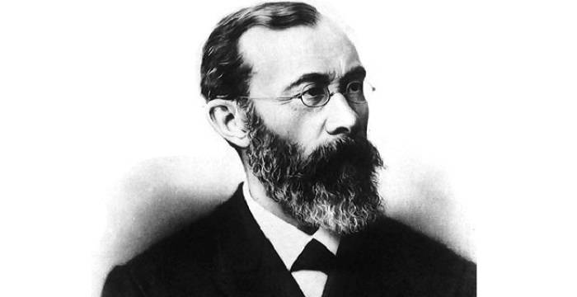
- WILHELM WUNDT – Wilhelm Wundt was a physician, physiologist, philosopher, and professor, known as father of psychology. Wundt, who distinguished psychology as a science from philosophy and biology, was the first person ever to call himself a psychologist.

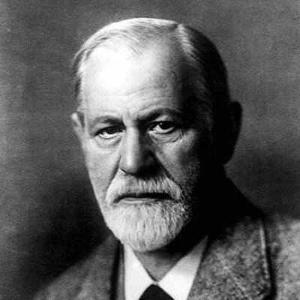
- SIGMUND FREUD - Sigmund Freud was an Austrian neurologist and the founder of psychoanalysis, a clinical method for treating psychopathology through dialogue between a patient and a psychoanalyst.

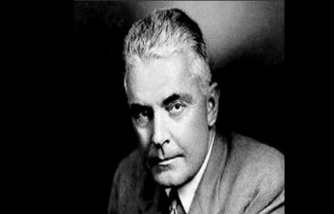
- J. B. Watson - John Broadus Watson was an American psychologist who established the psychological school of behaviorism. Watson promoted a change in psychology through his address Psychology as the Behaviorist Views it, which was given at Columbia University in 1913

INITIATIVE TAKEN BY SCHOOL FOR PSYCHOLOGY

- Educational tour 2. Field Visit 3. Interaction of student with Psychologist, counsellors and mental health expert 4. Promote student to do study to gain practical knowledge of subject.
Conclusion
Psychology is a very diverse field, one that is expected to see tremendous growth. There is no person who is just a ‘psychologist’. Since psychology is the study of human mind and behavior, it has numerous applications in all walks of life — work, family, relationships, sports, industries and in organizational spaces. As a result, one has the option to choose from a varied range of specializations, including but not limited to forensic psychology, counseling psychology, clinical psychology and organizational/industrial psychology.

