ON LINE DANCE EDUCATION
Introduction
To move around the rhythm of music by making a series of steps. Dance is of the most beautiful art forms and is also a beautiful way of expression.
- Online Dance Classes in India
- K.Jyotirmaye .P -Bangalor
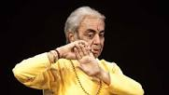
- Tunlapali N- Autonagar, Krishna C .Manjula Manjunath – Nagarbhavi- Bangalor Ohio- U S A-We have created a 2019 ranking of the best colleges in Ohio that offers Dance degrees to help you find a school that fits your needs. Each school ranking is based on the compilation of our data from reliable government sources , student surveys, college graduate interviews and editorial review.
Ohio- North Pointe Dance Academy Billed Nonthly
Top International Dance School
- The Royal Ballet School
- Joffrey Academy of Dance
- The Juilliard School Birju MAHARAJ
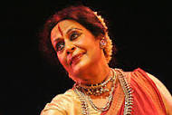
4.Canads National Belle School
Scope-
1. clubs
- Cabarets
- Performing Dance Companies Sonal Man Singh
4.Private Dance School
5. National & Regional Dance Development bodies.
Dance Classes Fees estimated fees in India
Rs,300 1to Rs .2,500 per month ,
On average dance classes cost anywhere from $ 40 to $ 160 per month.

