Introduction
When considering music education, most people don't immediately think of studying online. Music is something that lends itself to being learned and experienced in person, but the fact is that excellent online music education is available as well. Many will be amazed by the amount of high quality resources that exist. Full courses, lessons, sheet music, and artistic exhibits are all available to study online for absolutely free, and we've found the best of them.

- MIT OCW:

Browse MIT's Music and Theater Arts course materials to find lectures, projects, multimedia content, and more for some of the very best in free online music education. Resources include Early Music, Schubert to Debussy, and The Supernatural in Music, Literature, and Culture.
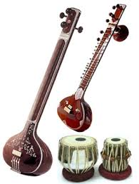
- Exploratorium Science of Music:
Explore the science of music in Exploratorium's exhibits, movies, and questions. The outstanding resources here will teach you to compose, mix, listen, and experiment.
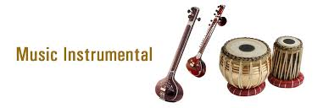
- Berklee Shares:
Find free music lessons from Berklee College of Music in this incredible resource. It offers a collection of self-contained music lessons, including music business lessons, guitar chords, and voice lessons.
- San Francisco Symphony Keeping Score:
Explore the world of music in this amazing resource from the San Francisco Symphony. Peruse the site to find a wealth of online exhibits in music, TV, and radio.
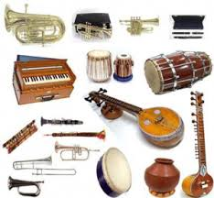
- Artsedge:
Use the Kennedy Center's Arts Education Network multimedia library to find music, lectures on music, and online exhibitions that will explore your musical education.
- Gresham Music Lectures:
Gresham College shares many of its past and current music lectures online. Check out their lectures to learn about music today, operas, innovation, and musical legacies.
Some important links are
https://www.mitsde.com
https://www.pointblankmusicschool.com
https://www.bimm.ac.uk/birmingham/
https://aaft.com/

