Online Education on Social Sciences
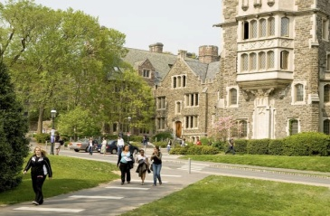
1. Harvard Business School online, every type of courses are available here.
: Subject including History, political science, and sociology etc.
School is in Boston, Massachusetts.
Site for Hope -Online.hbs.com, www.udem.com, www.emtyonline.com HTTP://alison.com
Liberty has never come from Government. Liberty has always come from the subjects of it. The history of liberty is a history of limitations of governmental power, not the increase of it.
Woodrow Wilson
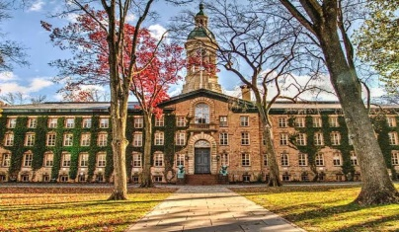
2. Hope title as Human Odessy to political Existentialism. Chhatrapati Shivaji

Princeton University for social sciences
Site for Hope –www.classcentral.com
Geography has made us neighbours. History has made us friends. Economics has made us partners, and necessity has made us allies. Those whom God has so joined together, let no man put asunder.
John F. Kennedy

Coins of Mauraya Dynasty Ellora Caves inside Kailash Temple

Online Education in History
Introduction of History:
What is history? It sounds such a simple question doesn't it? But it can cause a lot of disagreement. Napoleon called it 'a myth' and Henry Ford called it 'bunk'! Other people think it is much more important, believing, like the American historian David McCullough that "History is who we are and why we are the way we are."
Whatever they think about the usefulness of history most people will, however, agree that history is the study of the past. In fact, historians are a bit like detectives - using evidence to find out what happened and why. This is not an easy job. You must be able to recognise evidence, decide how useful it is and come to conclusions based on what you have found out.
1. Harvard University
Cambridge, Massachusetts
The nation’s oldest institution of higher learning, Harvard University was established in 1636 by the Massachusetts Bay Colony. The Harvard Extension School offers several distance learning programs, including bachelor o farts.
Tuitions
Extension School Undergraduate: $1700 per course.
Extension School Graduate Degree: $27500-$33000
School Profile
Address: Massachusetts Hall Cambridge, MA02138
Phone Number: (617) 495-1000
Website: http://www.harvard.edu
2. University of Central Florida
Orland, Florida
Established in 1963 as a technological institution, the University of Central Florida now host the
Largest enrolment of any American college or University. UCF offers over 200 degree options, UCF also provide degree for Bachelor Of arts in History
Tuitions
Under Graduate tuition: $105 in state / 150 out of state.
Graduate tuition: $288 in state/288 out of state
School Profile
Address: 4000 Central Florida Blvt, Orlando, FL32816 USA
Website: https://www.ucf.edu
3. University of Massachusetts –Lowell
Lowell, Massachusetts
UMass Lowell was founded in disciplines such as engineering, humanities, and business.
The bachelor degree of arts with a concentration in History at UMass Lowell allows students to fully customize their degree.
Tuition:
Undergraduate, online students: $380 pre credit.
Graduate students: $575
School Profile
Address: University Crossing, Suite 420,220 Pawtucket St, Lowell MA 01854
Phone Number: (978) 934-4000
Website: http://www.uml.edu

Scope of History
The scope of history is very vast and varied. It deals with everything that ever happened. Every event that has ever happened in the world has been it political, social, economic, cultural, religious, scientific, or technological came under the scope of history. Hence the scope of history is very wide and vast.

