Introduction: - Economics is a social science concerned with the production, distribution, and consumption of goods and services. It studies how individuals, businesses, governments, and nations make choices on allocating resources to satisfy their wants and needs, trying to determine how these groups should organize and coordinate efforts to achieve maximum output.

Understanding Economics:
One of the earliest recorded economic thinkers was the 8th-century BC Greek farmer/poet Hesiod, who wrote that labor, materials, and time needed to be allocated efficiently to overcome scarcity. But the founding of modern Western economics occurred much later, generally credited to the publication of Scottish philosopher Adam Smith's 1776 book, An Inquiry Into the Nature and Causes of the Wealth of Nations.
Online education in economics:

CAREER SCOPE IN ECONOMICS:-
( 1.) Economist ( 2.) Financial risk analyst (3.) Data analyst ( 4.) Financial planner (5.) Accountant (6.) Economic researcher (7.) Financial consultant ( 8.) Investment analyst
( 9.) Actuary(10.)Public sector roles

.
AMARTYA SEN
Amartya Kumar Sen is an Indian economist and philosopher, who since 1972 has taught and worked in the United Kingdom and the United States.
Born: 3 November 1933 (age 86 years), Santiniketan
Spouse: Emma Georgina Rothschild (m. 1991), Eva Colorni (m. 1978–1985), Nabaneeta Dev Sen (m. 1958–1976)
Awards: Nobel Memorial Prize in Economic Sciences, MORE
Education: Presidency University, Trinity College, MORE
Quotes:-
While I am interested both in economics and in philosophy, the union of my interests in the two fields far exceeds their intersection.
The curriculum of the school did not neglect India's cultural, analytical and scientific heritage, but was very involved also with the rest of the world.
But the idea that I should be a teacher and a researcher of some sort did not vary over the years
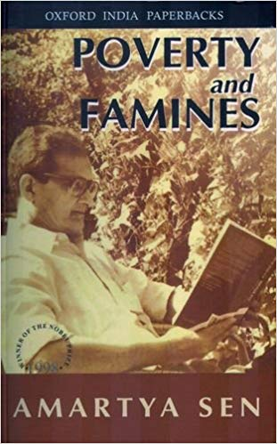
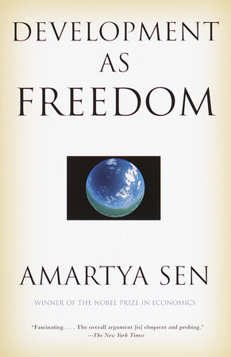
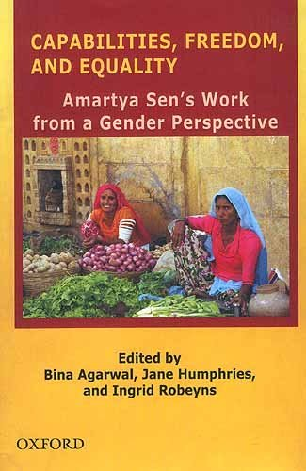
SOME FAMOUS BOOKS BY AMARTYA SEN:-Picture …
Link of tutorials to study eco :
- https://youtu.be/8JYP_wU1JTU
- https://youtu.be/nxwlhb1Arfg?list=PLWPirh4EWFpGEloIVSDKN9euzTIFUQbLl
- https://youtu.be/aJkigLWeaQM
Conclusion: Economics is most significant part of social science it prevails the scientific approach to understand socio economics structure.

