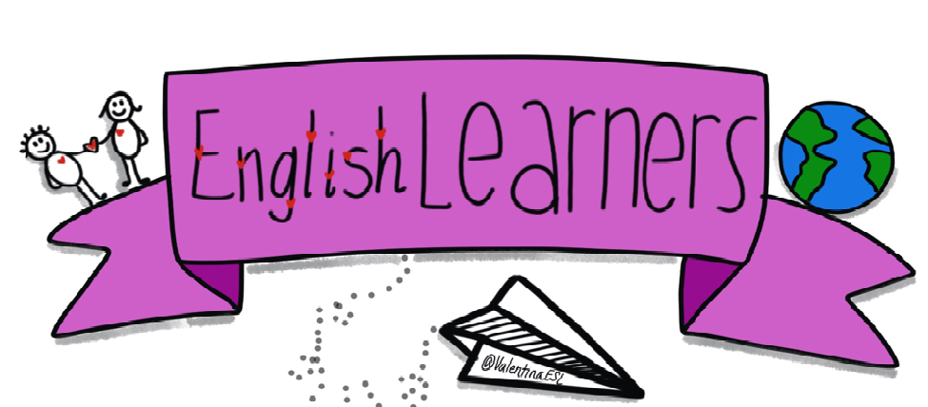
ONLINE EDUCATION
English Language is a vital tool for communication. It is not only a means of communicating thoughts and ideas, but it builds friendships, economic relationships and cultural ties. It shapes the way people perceive the world and it also helps to define culture of any society. It opens our minds and guides us into a magical world of fancies and dreams. To certain the proper learning of language helps us to develop ourselves, our minds, and also our personality.
IMPORTANCE OF ENGLISH: - English has been considered to be the first global Lingua Franca. In today’s modern world English language has become part and parcel of every existing field. It has been an international language of communication, business, Science, Information technology, Entertainment and so on. Earlier everyone was considered to be literate by their degrees and diplomas, but the knowledge of English language makes an individual literate in today’s world. Though many countries do have English as their native language, those who have the command over English Language are considered and respected as highly educated. Moreover the oceans of career opportunities are open to those people who speak English throughout.
CAREER IN ENGLISH: (1) MEDIA AND JOURNALISM (2) PUBLISHING (3) ADVERTISING AND PUBLIC RELATIONS. (4)THEATRE AND ACTING (5) EDUCATION (6) TEACHING (7) TRANSLATOR (8) LANGUAGE TRAINER (9) BPO (10) VOICE ACCENT TRAINERS
BEST UNIVERSITIES FOR ENGLISH LITERATURE
Besides obvious top choices like Oxford, Stanford, Cambridge and Harvard, here’s a list of Universities best known for their English Literature course.
(1)Yale(2)Princeton(3)University of Sydney(4)National University of Singapore(5)University of Toronto(6)UCL(7)University of British Columbia(8)Lady Sri Ram College(9)Xavier’s College(10)Delhi University
SKILLS YOU GAIN: (1)Excellent written and verbal communication(2)Creative thinking(3)Analytical and critical thinking(4)Ability to understand and learn large chunks of information(5)Ability to understand(6)abstract concepts and ideas(7)Being in touch with human psychology and behavior

ONLINE MASTER COURSE IN ENGLISH:-

Ohio University Online Master's in English Athens, Ohio

Arizona State University Online Master's in English

National University La Jolla, California

Wayland Baptist University Online Master's in English Plainview, Texas

University of Memphis Online Master's in Teaching English Memphis, Tennessee

Morehead State University Master of Arts in English Online Morehead, Kentucky
LINKS FOR ONLINE CLASSES:
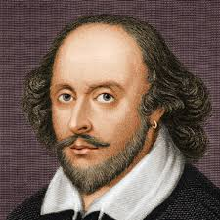
(1)Learn American English Online on YouTube(2)Beginning English(3)Intermediate English(4)Advanced English(5)Words / Phrases / Vocabulary(6)Bilingual Sites English and Your Language) (7)Online Tutoring(8)Business English(9)Community Sites(10)Living in the U.S.(11)English Pronunciation
William Shakespeare
William Shakespeare was an English poet, playwright, and actor,
Widely regarded as the greatest writer in the English language and the world's
greatest dramatist.
He is often called England's national poet and the "Bard of Avon".
Born: April 1564, Stratford-upon-Avon, United Kingdom
Died: 23 April 1616, Stratford-upon-Avon, United Kingdom
Books: The Complete Works of Shakespeare, Sonnet 116, MORE
Poems: Shakespeare's Sonnets, Sonnet 116, MORE
QUOTES:-
All that glitters is not gold
By the pricking of my thumbs, Something wicked this way comes
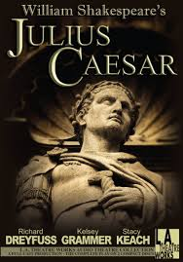
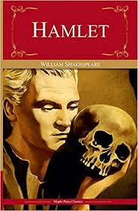
Open, locks, Whoever knocks!
The lady doth protest too much, methinks.
BOOKS OF SHAKESPEAR:-

WILLIAM WORDSWORTH:
William Wordsworth was an English Romantic poet who, with Samuel Taylor Coleridge, helped to launch the Romantic Age in English literature with their joint publication Lyrical Ballads. Wikipedia
Born: 7 April 1770, Cockermouth, United Kingdom
Died: 23 April 1850, Rydal Mount & Gardens, Rydal, United Kingdom
Poems: I Wandered Lonely as a Cloud, The Prelude, MORE
Education: Hawkshead Grammar School, University of Cambridge, St John's College, Cambridge
QUOTES:
The child is father of the man.
Getting and spending, we lay waste our powers.
That inward eye Which is the bliss of solitude.
PERCY BYSSHE SHELLEY:
Percy Bysshe Shelley was one of the major English Romantic poets, who is regarded by some as among the finest lyric and philosophical poets in the English language, and one of the most influential. Wikipedia
Born: 4 August 1792, Horsham, United Kingdom
Died: 8 July 1822, Lerici, Italy
Poems: Ozymandias, Ode to the West Wind, To a Skylark, Adonais, MORE
Spouse: Mary Shelley (m. 1816–1822), Harriet Westbrook (m. 1811–1816)
QUOTES:
O, wind, if winter comes, can spring be far behind?
Nothing in the world is single; All things by a law divine In one another's being mingle:— Why not I with thine?
Oh, lift me as a wave, a leaf, a cloud! I fall upon the thorns of life! I bleed!

Cognitive Exchange Program: - The CEP had been organized for 7 weeks with the students of Sanfrancisco (USA) where students leant about memorization, clear diction, voice modulation, body language, healthy competition was organized and children performances were highly appreciated. Classes’ 6-12 students take part in Cognitive Exchange Program.
(Jaiswalvineet24@gmail.com)
Conclusion: - English is globally accepted language which works as the bridge amongst different languages. So, we cannot escape from it.IHS always tries to encourage the students to speak this language.

