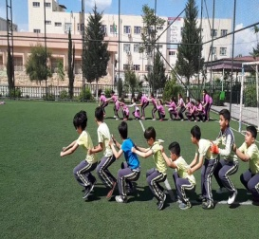
Physical education Introduction
Nowadays in the rapidly changing culturing cultural environment,physical education is confronting a plethora of problems,challenges and opportunities
Quotation
intelligence and skill can only function at the peak of their capacity when the body is healthy and strong( john f.kennedy)
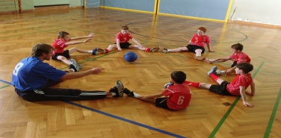
career scope
- Coaching career in physical education
- Teaching career in physical education
- Health related career
- Administration related career
Link for college and school on line education
- vist, http://www.keiseruniversity.edu/consumer-information/
- lnipe.edu.in
- .http://igipess1.du.ac.in:8080/web/home_page.jsp
- www.bhu.ac.in
http://puchd.ac.in
Importance
- Physical education may help prevent disease, improve overall health and wellness, maintain social and emotional balance through building relationships, enhances a students' academic learning and performance, and fosters positive life-long habits that lead to a happier life
Punch line :- “if a first you don’t succeed,try something harder”
School achievement :- We are dedicated to maintaining the highest standards of education and sports . Our high quality learning approach ensures that we help every child achieve excellence, and to emerge with a healthy and physical fitness understanding of the world that comes from an international school education The achievements, successes or accomplishments we gain in school are the part of best school life years. Those achievements in middle, high school or college student life may include personal academic achievements and sports or extracurricular achievements.

