Online Science Education
In the last 20 years, the Internet has grown from being nearly non-existent into the largest, most accessible database of information ever created. It has changed the way people communicate, shop, socialise, do business and think about knowledge and learning. “Online education is electronically supported learning that relies on the Internet for teacher/student interaction and the distribution of class materials.”
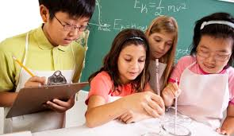
Albert Eintein quoted, “This world is grand and there lies an ocean of undiscovered findings”
Science is one of the most popular and universal subjects and online courses range from beginner to advanced levels. Areas of study include neuroscience, genotyping, DNA methylation, innovations in environmental science, modern astrophysics and more from top universities and institutions worldwide.The good thing about science is that it's true whether or not you believe in it. ― Neil deGrasse Tyson
There are various websites and universities which provide best online education diplomas, certification, bachelor’s and master’s degrees. Here are a few websites and colleges which provide best courses to be studied online.
- IISER Pune (www.iiserpune.ac.in)
- Indian Institute of Sciences, Bangalore
- The National program on technological enhancement and learning (www.nptel.iitm.ac.in)
- Indian Institute of Science, IIT, NPTEL.
- www.openuniversity.edu
- www.edx.org
- www.udemy.com
- The Harvard University (www.online-learning.harvard.edu)
- New Mexico Institute of Mining & Technology (www.nmt.edu)
- North Carolina State University (www.online-distance.ncsu.edu)
- University of Massachusettes Amherst (www.umassonline.net)
- Hamline University (www.hamline.edu)
- Colorado state University-Global Campus (www.online.colostate.edu)
- Oregon State University (www.ecampus.oregonstate.edu)
- University of Nebraska (www.unk.edu)
- University of Texas Arlington (www.academicpartnerships.uta.edu)
About US- IHS organises Science Exhibition every year for students from grade I to XII. This year the exhibition‘s theme was Global Warming, which is affecting the globe adversely. The event was organised on 23rd January 2019 in the presence of the President, Dr. Suman Kumar Mishr who resides in Ohio, USA.The exhibition was inaugurated by Padam Shree Prof. O.N. Srivastava, who is an Indian Material Physicist and Emeritus Professor of BHU & VP for India and South Asia of the International Association of Hydrogen Energy known for his contribution to the discipline of Nanotechnology & Hydrogen Energy.
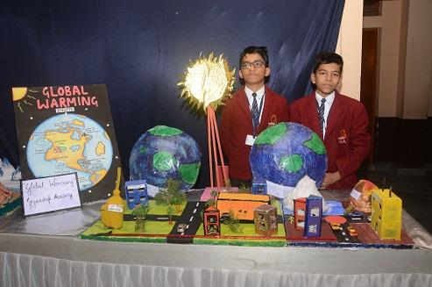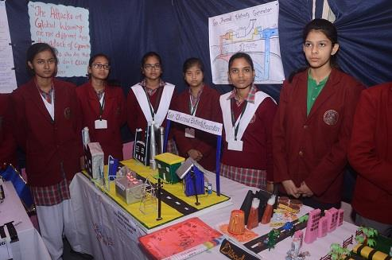
The School is proud to possess a Computer Lab, Science Lab and an Einstein Lab for budding scientists in our school. These labs have been thoughtfully designed to satisfy the inquisitiveness and quest for innovation and research.
Conclusion- “The saddest aspect of life right now is that gathers knowledge faster than society gathers wisdom”― Isaac Asimov. Students earning their degree online have a far bigger list of colleges and universities to choose from, as opposed to students choosing between attending a handful of local schools. Online universities across the country are now accessible.

Priyanka Bakshi, PRT (Science)

