"YogasyaChittaVrittiNirodha"
What is yoga-?
The word “yoga” essentially means, “that which brings you to reality”. Literally, it means “union.” Union means it brings you to the ultimate reality, where individual manifestations of life are surface bubbles in the process of creation.
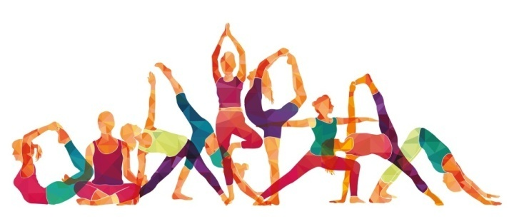
We live in the fast lane of an ever-changing world, running in place while trying to catch up with ever-changing technology. Every day we face enormous challenges juggling finances, family, career, and relationships which is exhausting because it feel like we’re running on empty.

Meditation!
What is Meditation?
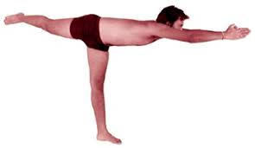
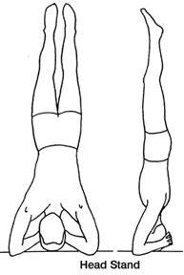
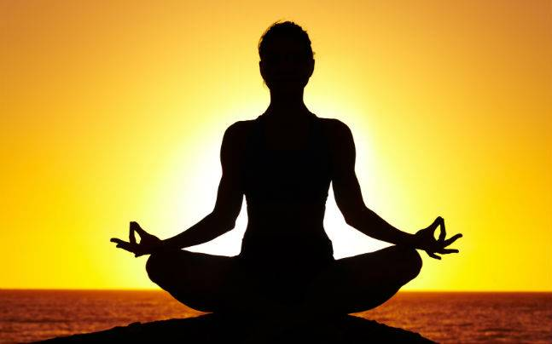

Meditation is a practice of aligning your mind, body and spirit by going deep within to access the power of your belief to create what you truly desire. Guided meditation, deep relaxation and mind-body techniques are not passing fads, trends, or New Age nonsense. They are researched and proven approaches that have lasting benefits for radiant health, happiness and self-empowerment.
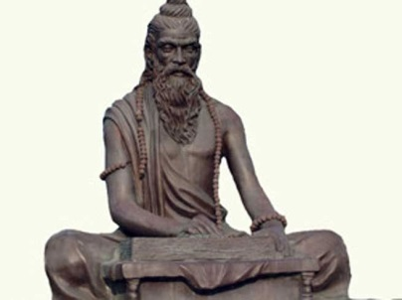
Patanjali
Yogi and mystic Sadhguru explores the incredible life
and capabilities of Patanjali, the father of modern yoga
and the author of the celebrated yoga sutras.

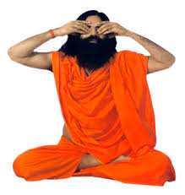
Work is my religion work is my praying work is the truth of world and life. ― Swami Ramdev
Benefit of yoga-
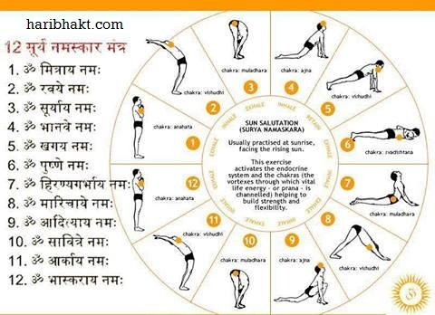
- Increase your flexibility, It helps to build muscle strength, Prevents from cartilage and joint breakdown, Maintain healthy lifestyle, Give your healthy lifestyle, Increase concentration, Relief from stress.
Courses & Eligibility
What are the courses to pursue in this field?
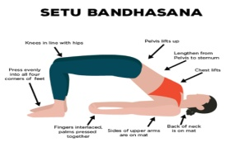
There are many courses available in this field by which students can make their career in this field. Some of the most sought courses are mentioned here:

Certificate Course:
- Certificate Course in Yoga (CCY): It is a one and a half month course with the eligibility of HSC passed. No age limit for this course.

Bachelor Course:
- Bachelor in Arts (Yoga Philosophy): Duration of this course will be three years with the eligibility of 10+2 from any stream securing minimum 45% marks.
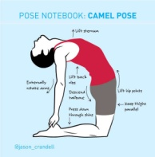
- UG. Diploma in Yoga Education: It is a one year duration course with six months internship with the eligibility of graduate from any stream with a certificate in Yoga.

Master Course:
- PG. Diploma in Yoga Therapy: It is a one year duration course with the eligibility of graduation with any stream from any recognized university.
- Master of Arts in Yoga: It is a two year duration course with the eligibility of minimum graduation from any stream.

Other Course:

- Advanced Yoga Teachers’ Training Course in Yoga (AYTTC): One month duration course with eligibility of certificate, diploma or graduation in yoga with two years teaching experience in yoga.
Some job titles are:
- Yoga Instructor, Yoga Therapist, Yoga Advisor, Yoga Specialist, Yoga Practitioner, Yoga Teacher, Research Officer- Yoga and Naturopathy, Yoga Aerobic Instructor, Yoga Consultant, Publication Officer (Yoga), Yoga Manager.

Books & Study Materials
Searching for good books of yoga?………….. Here are some books which you can use to study yoga:
The Wisdom of Yoga: A Seeker’s Guide to Extraordinary Living by Stephen Cope
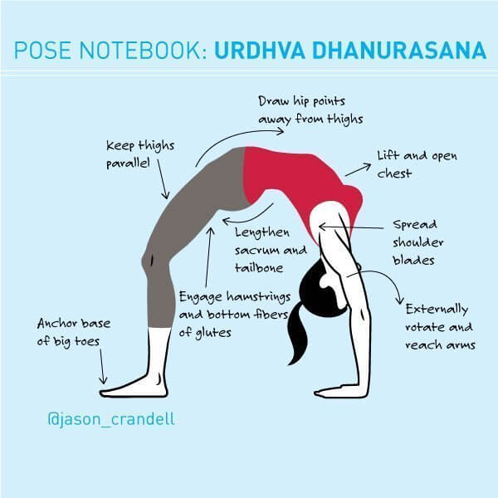
Yoga: The Greater Tradition by David Frawley
Light on Yoga: The Bible of Modern Yoga by B.K.S. Iyengar
The Heart of Yoga: Developing a Personal Practice by T.K.V. Desikachar
Yoga as Medicine by Timothy McCall
Yoga Anatomy by Leslie Kaminoff
Yoga Sequencing: Designing Transformative Yoga Classes by Mark Stephens.

Our school initiative
Developing an emotional and mental health through yogic activities.
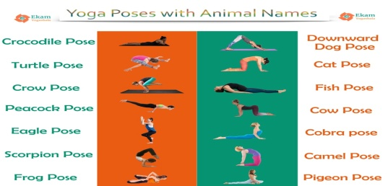
• Developing harmony understanding of yogic practices and apply this understanding accordingly in one’s life and living.
• Developing a healthy habit and lifestyle in children.
• Developing humane values in children.
• Developing physical, with the nature and universe.
Conducting Sahaj Yoga session for better understandment of yoga.
Celebrating Yoga Day on International Yoga diwas.
Conclusion-
Yoga is the medicine for nearly every problem. As you practice yoga, it does not only help you to improve your physical body but also helps in maintaining your inner peace and relaxing your mind. Thus, there is nothing that yoga will not help. Moreover, yoga is not just a one-day practice; it's a lifelong commitment.

